Architectural Design Document

**Introduction**

Design and develop a RISK Strategy game using suitable software design architecture with iterative software development approach to make a modular design and deliver several working coherent modules in small increments or builds. We implemented a Model View Controller (MVC) architectural design model. It was an effort to use extreme programming key features such as Pair programming, Collective ownership, Coding Standards and many more with the focus of System Metaphor.

**Overall Design Architecture**

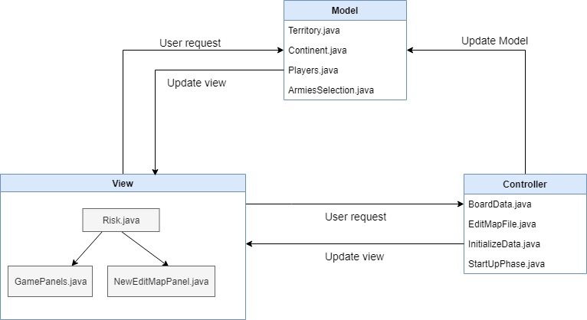

**Module descriptions:**

|  |  |
| --- | --- |
| **Model** | **Description** |
| Terittory.java | This model class contains the Territory data generated from map file. |
| Players.java | This model class contains the data of Players. |
| Continent.java | This model class contains the Continent data generated from map file. |
| ArmiesSelection.java | This model class set the Number of initial armies depending on number of players playing. |
| **View** |  |
| Risk.java | A User-Interface to Launch the Game Play, Create Map or Edit Map and quit the Game. |
| NewEditMapPanel.java | A User-Interface to edit existing map file. |
| GamePanels.java | A complete User-Interface to play game, select players. |
| **Controller** |  |
| BoardData.java | This Controller used to parse map file, validate map file and generate map data from it. |
| EditMapFile.java | This Controller is used to edit existing map file and save the new edited map file. |
| Fortification.java |  |
| InitializeData.java | This controller used to initialize data for game play and commence the start-up phase of RISK game. |
| StartUpPhase.java | Process the start-up phase, assign the territories to players in round-robin fashion. |
| **Exception** |  |
| InvalidMapException.java | This class is used to print InvalidMapException message if map is not valid. |
| **Validate** |  |
| MapValidator.java | This class is used to validate the map file. |
| ConnectedGraph.java | Class to check is graph is connected or not? |
| **Observer** |  |
| Obsever.java | Observer class of Observer design pattern. |
| Subject.java | Subject class of Observer design pattern. |
| **Strategy** |  |
| Context.java | Context class of Strategy pattern. |
| Strategy.java | Strategy class of Strategy pattern. |
| **Test** |  |
| ControllerTestSuite.java | Test suite class of controller folder. |
| ReinforcementTest.java | Test all methods of Reinforcement.java class. |
| StartUpPhaseTest.java |  |
| ArmiesSelectionTest.java | This test class test all methods of ArmiesSelection.java Model class. |
| ContinentTest.java | This test class test all methods of Continent.java Model class. |
| ModelsTestSuite.java | Test suite class of models folder. |
| PlayersTest.java | This test class test all methods of Players.java Model class. |
| TerritoryTest.java | This test class test all methods of Territory.java Model class. |
| MapValidatorTest.java | Test all methods of MapValidator.java class. |
| MapValidatorTestIncorrectMap.java | Reads Incorrect maps and test it. |
| ValidateTestSuite.java | Test suite class of validate folder. |
| RiskTestSuite.java | Run all test cases together.(Test suite class) |

**Class Diagrams**

**Controller Implementation Class Diagram**

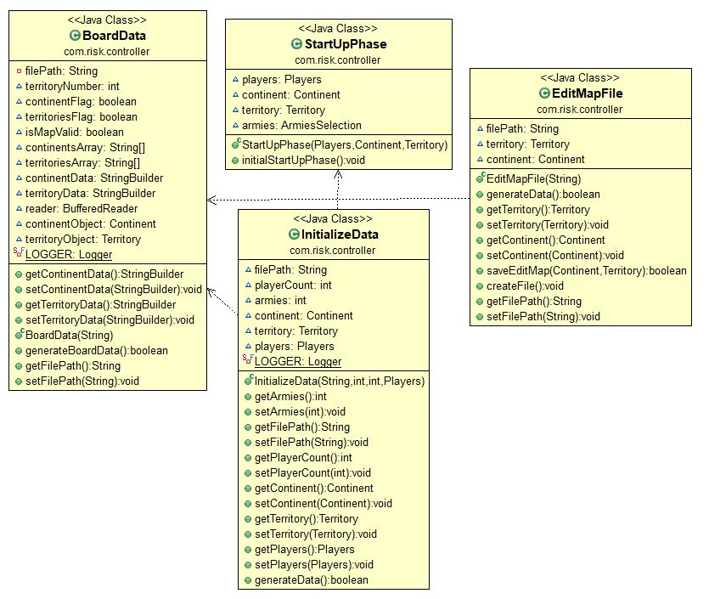

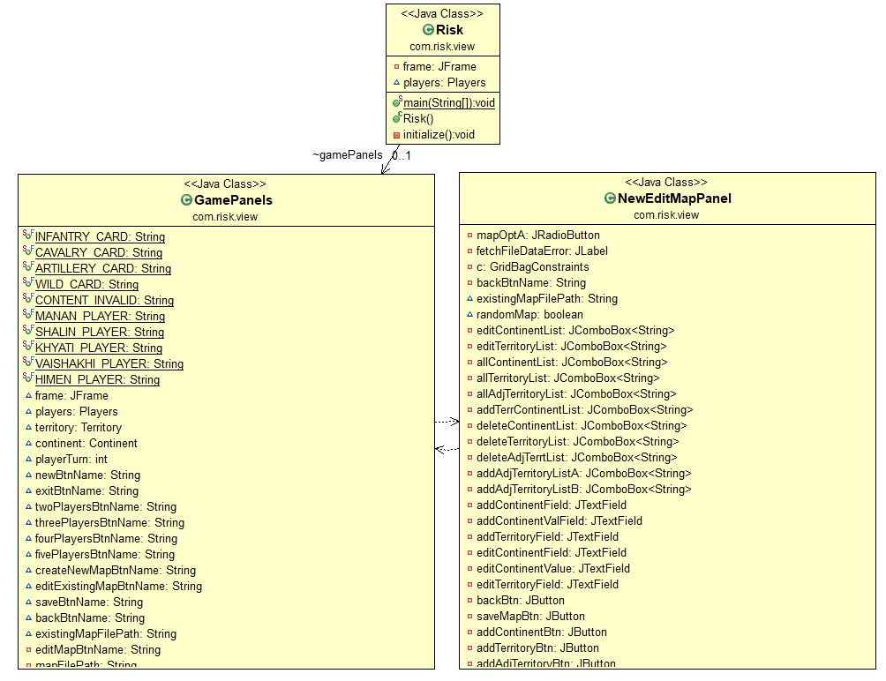**View Implementation Class Diagram**

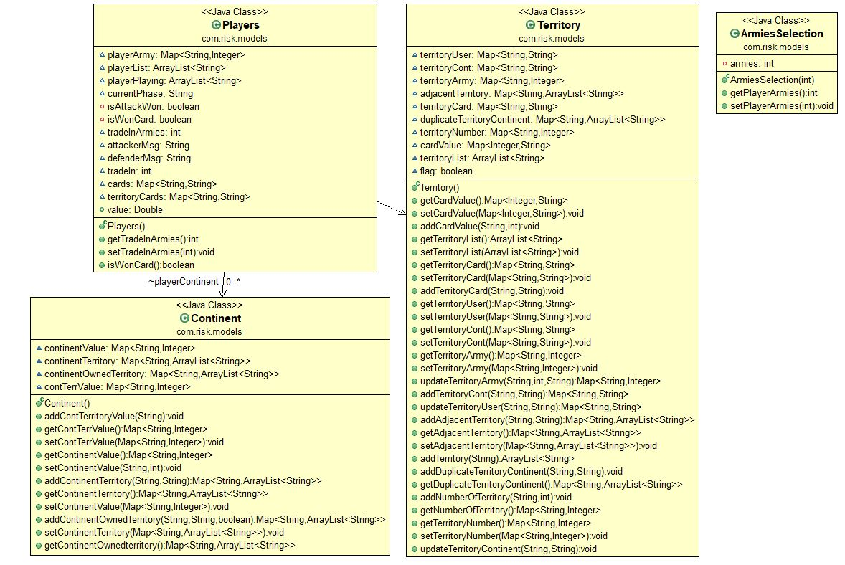**Model Implementation Class Diagram**

**Test Implementation Class Diagram**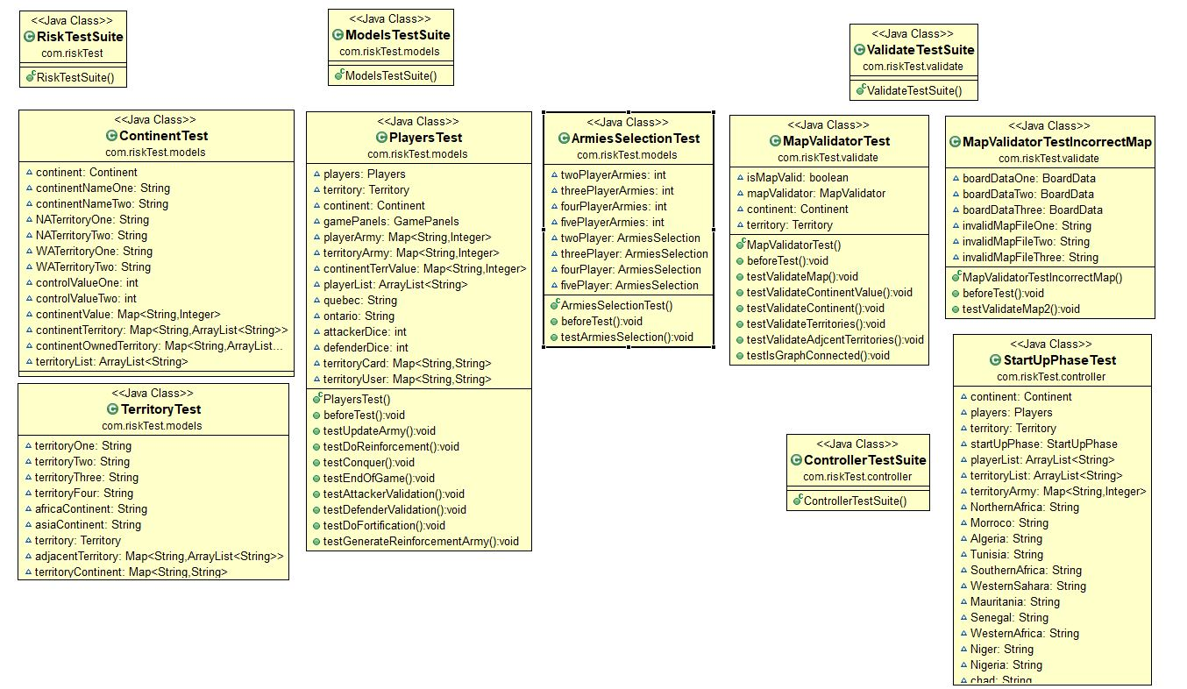

**Rules Followed:**

Rules followed of Ultra Board Games : <http://www.ultraboardgames.com/risk/game-rules.php>